**5.Git-HOL**

1. **Verify if master is in clean state.**

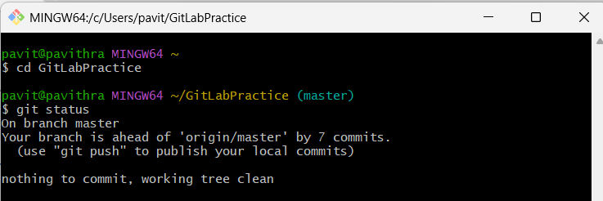

1. **List out all the available branches.**

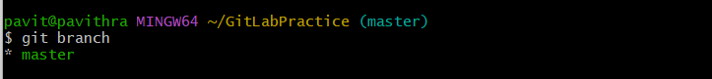

1. **Pull the remote git repository to the master.**

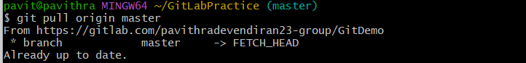

1. **Push the changes, which are pending from “Git-T03-HOL_002” to the remote repository.**

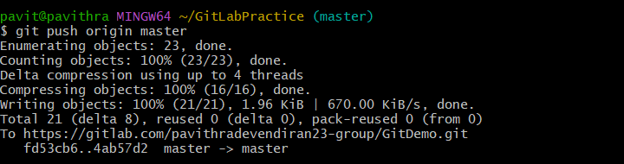

1. **Observe if the changes are reflected in the remote repository.**

